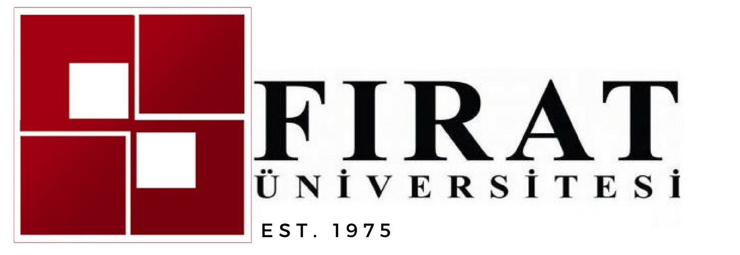
INTERNATIONAL STAFF WEEK
07 - 11 May 2018
Deadline for application is 27th of April 2018. We will accept up to 30 participants.

Application Form

TITLE (Prof, Dr, Mr, Ms)
NAME (surname, name)
DEPARTMENT / UNIT/OFFICE
POSITION
YOUR MAIN AREAS OF RESPONSIBILITY
E-MAIL
HOME INSTITUTION
ERASMUS CODE
ADDRESS
SPECIAL DIETARY NEEDS
What do you expect from this International Week?

Please send the application form to our email address erasmus@firat.edu.tr

